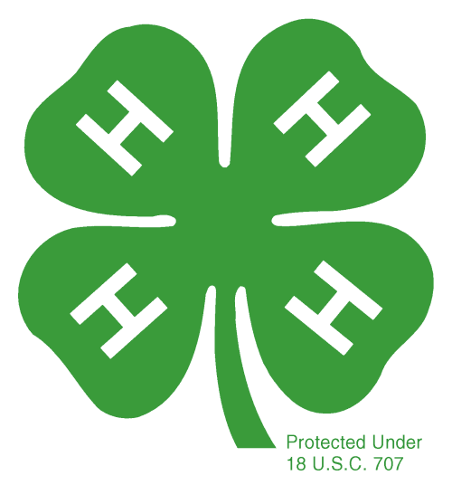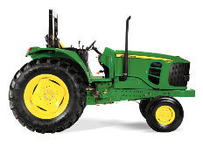

Schoharie County   
4-H Tractor Safety

Certification Course

**A Three Day Series**

**Mondays: April 1 & 8, 5-9 p.m.**

**Saturday: April 13, 9- 4 p.m.**

**Curtis Mott Building, SUNY Cobleskill**

**Must attend all classes**

Cornell Cooperative Extension of Schoharie and Otsego Counties will be offering the Safe Tractor and Machinery Operator’s Certification Course in cooperation with SUNY Cobleskill’s Agriculture Engineering Department.

This safety course is available to youth ages 14 and up. Any youth under the age of 16 must complete this program in order to receive a Certificate of Exemption for farm equipment and tractor operation.

**Classroom and driving skill instruction included.**

**Fee is $20. Class is limited to 15 students.**

**Registration Deadline March 22**

**Contact Teresa Adell, tla47@cornell.edu Or 518-234-4303**